Acts 18:1-28
From Athens Paul traveled to Corinth, about 97 kilometers (60 miles) to the west. Before reaching Corinth Paul would have passed the site where the athletic events known as the Isthmian Games were held every 2 years. These ranked second in importance to the Olympic Games.

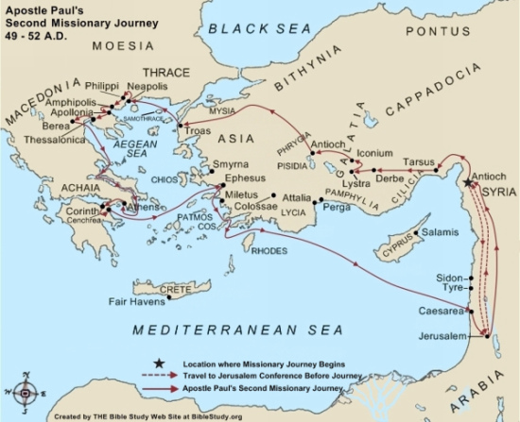
In Corinth
¹ After this, Paul left Athens and went to Corinth. ² There he met a Jew named Aquila, a native of Pontus, who had recently come from Italy with his wife Priscilla, because Claudius had ordered all Jews to leave Rome. Why were Aquila and Priscilla in Corinth? Paul went to see them, ³ and because he was a tentmaker as they were, he stayed and worked with them. Why did Paul work? ⁴ Every Sabbath he reasoned in the synagogue, trying to persuade Jews and Greeks. How did Paul spend his Saturdays?
⁵ When Silas and Timothy came from Macedonia, Paul devoted himself exclusively to preaching, testifying to the Jews that Jesus was the Messiah. Why do you think it took Silas and Timothy such a long time to meet up with Paul? (Hint: I Thessalonians 3:1-8 This is a letter Paul wrote to the Thessalonians' congregation) ⁶ But when they opposed Paul and became abusive, he shook out his clothes in protest and said to them, “Your blood be on your own heads! I am innocent of it. From now on I will go to the Gentiles.” What was Paul's reaction to the Jews who were abusive?
⁷ Then Paul left the synagogue and went next door to the house of Titius Justus, a worshiper of God. What did we learn the phrase "a worshiper of God" meant? ⁸ Crispus, the synagogue leader, and his entire household believed in the Lord; What do we learn about Crispus? and many of the Corinthians who heard Paul believed and were baptized.
⁹ One night the Lord spoke to Paul in a vision: “Do not be afraid; keep on speaking, do not be silent. ¹⁰ For I am with you, and no one is going to attack and harm you, because I have many people in this city.” What message did the Lord give to Paul in a vision? Why? ¹¹ So Paul stayed in Corinth for a year and a half, teaching them the word of God. What did Paul do while staying in Corinth for a year and a half?
¹² While Gallio was proconsul of Achaia, the Jews of Corinth made a united attack on Paul and brought him to the place of judgment. ¹³ “This man,” they charged, “is persuading the people to worship God in ways contrary to the law.” What was the charge?
¹⁴ Just as Paul was about to speak, Gallio said to them, “If you Jews were making a complaint about some misdemeanor or serious crime, it would be reasonable for me to listen to you. ¹⁵ But since it involves questions about words and names and your own law—settle the matter yourselves. I will not be a judge of such things.” What was Gallio's decision? ¹⁶ So he drove them off. ¹⁷ Then the crowd there turned on Sosthenes the synagogue leader and beat him in front of the proconsul; and Gallio showed no concern whatever. What happened to Sosthenes the synagogue leader?

Notes:

Corinth - was a strategic port city and a prosperous commercial center. Corinth had been destroyed by the Romans in 146 B.C. because of its opposition to Roman rule. The population was either killed or sold into slavery. In 44 B.C. Julius Caesar ordered that Corinth be rebuilt as a Roman colony. The population consisted of liberated slaves and ex-service soldiers from Italy, Roman officials, businessmen, and craftsmen. Corinth was well known for its pottery and brass. The Corinth of Paul's time had the reputation of being excessively immoral. Ritual prostitution in the temple of Aphrodite was common. It is reported that there were more than a thousand slaves who engaged in the practice of prostitution.

Titius Justus - Titius Justus was Gentile convert to Judaism who had been worshipping with the Jews prior to his becoming a Christian.

Gallio - From an inscription found near Delphi, Gallio was proconsul from 52-53. Gallio was the brother of philosopher Seneca, who was a tutor of Nero. Later he was executed by Nero for involvement in a plot to overthrow the emperor.

Priscilla, Aquila and Apollos
¹⁸ Paul stayed on in Corinth for some time. Then he left the brothers and sisters and sailed for Syria, accompanied by Priscilla and Aquila. Who traveled with Paul? What was in Syria? Before he sailed, he had his hair cut off at Cenchreae because of a vow he had taken. Why would Paul end his vow? ¹⁹ They arrived at Ephesus, where Paul left Priscilla and Aquila. He himself went into the synagogue and reasoned with the Jews. ²⁰ When they asked him to spend more time with them, he declined. Who wanted Paul to spend more time with them? ²¹ But as he left, he promised, “I will come back if it is God’s will.” Then he set sail from Ephesus. Who stayed behind in Ephesus? ²² When he landed at Caesarea, he went up to Jerusalem and greeted the church and then went down to Antioch. Jerusalem was high above sea level which is why people went "up" to Jerusalem.
²³ After spending some time in Antioch, Paul set out from there and traveled from place to place throughout the region of Galatia and Phrygia, strengthening all the disciples. This is the beginning of Paul's third missionary journey. Why did Paul make this trip?
²⁴ Meanwhile a Jew named Apollos, a native of Alexandria, came to Ephesus. He was a learned man, with a thorough knowledge of the Scriptures. What do we learn about Apollos? ²⁵ He had been instructed in the way of the Lord, and he spoke with great fervor and taught about Jesus accurately, though he knew only the baptism of John. What does it mean to know only the baptism of John?²⁶ He began to speak boldly in the synagogue. When Priscilla and Aquila heard him, they invited him to their home and explained to him the way of God more adequately. What do you think Priscilla and Aquila shared with Apollos?
²⁷ When Apollos wanted to go to Achaia, the brothers and sisters encouraged him and wrote to the disciples there to welcome him. What cities were in the region of Achaia? When he arrived, he was a great help to those who by grace had believed. ²⁸ For he vigorously refuted his Jewish opponents in public debate, proving from the Scriptures that Jesus was the Messiah. What message did Apollos bring with him?

Notes:
Vow - The vow involved letting one's hair grow for an extended period of time. It is likely that Paul during the difficult period in Corinth made such a vow.

Ephesus - Leading commercial city of Asia Minor, the capital of provincial Asia. It boasted a pagan temple to the Roman goddess Diana one of the seven wonders of the ancient world.

Baptism of John - It is generally believed that many of John the Baptist's disciples left after his death, telling those who they met what they knew of John and Jesus.

